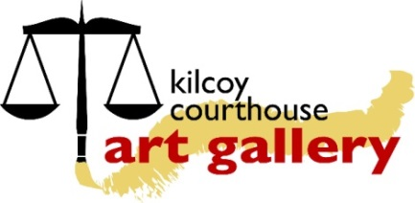 | KILCOY ART SOCIETY INC (KASI)  35 Hope Street / PO Box 162, Kilcoy, Qld. 4515  Ph: (07) 5497-2000  Website: www.kilcoyart.org.au  Email: ‘Contact us’ via above website  ABN 41 492 607 859

KASI Membership Application

Name
Address
Phone | Home: | Mob:
Email

I would like to JOIN / RE-JOIN (please circle one) the Kilcoy Art Society Inc (KASI) as:
- An Exhibiting Artist on Gallery roster – [ $25 per year and 15% commission]
- An Exhibiting Artist NOT on Gallery roster – [ $60 per year and 30% commission]
- A Non- Exhibiting Artist - [ $20 per year]
- A Friend of the Gallery (FOG) – [ $5 per year]

For Exhibiting Artist Members Only: Bank Account that you want to be paid into:

A/C Name: _________________________ BSB: ___________ A/C Number: _______________________

I am paying for my membership by:
- Cash/credit card at the Gallery
- Bank transfer: Kilcoy Art Society
BSB: 633000
Account Number: 178952461
Please put your name on the reference line.

New membership applications will be presented at the next General Meeting for ratification.
I agree to follow the Kilcoy Art Society’s values (as set out in KASI Membership Information).

Signed _______________________________________________ Date ______/______/______

